Step-by-Step Explanation of 3D Nonlinear Image Registration (FNIRT Conceptual Example)

This section explains the conceptual workflow of 3D nonlinear image registration using FNIRT. The method refines the initial affine alignment obtained from FLIRT by estimating a nonlinear deformation field that maps the subject’s anatomical T1 image to the MNI standard space. FNIRT models local anatomical differences using control points and regularization constraints, allowing the moving image to smoothly deform so that it better matches the reference template. This process improves spatial correspondence between brain structures and enables accurate normalization for subsequent analysis.

STEP 0 : Inputs
We have:
Reference image (MNI):
$$f(x),x=(x,y,z)^{T}$$
Moving image (T1):
$$g(x)$$
Initial affine matrix from FLIRT:
$$A∈R^{4×4}$$
Regularization weight:
$$λ$$
Control point coefficients:
$$c$$

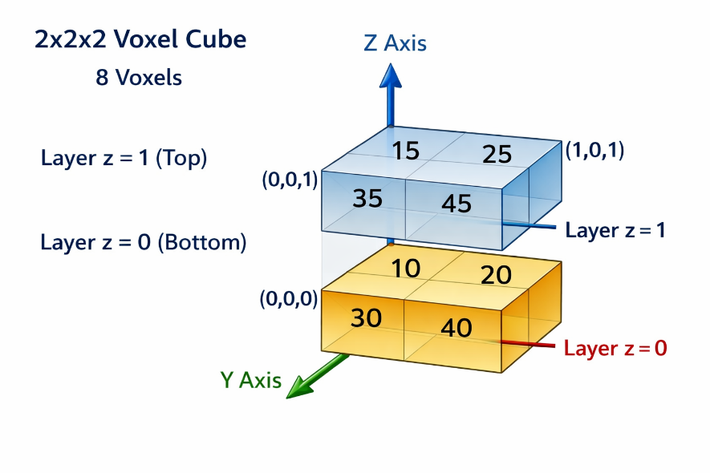
For Example:
Reference image $f(x,y,z)$
2×2×2 cube:
$$f=\left[\begin{aligned}\left[\begin{matrix}10 & 20 \\ 30 & 40\end{matrix}\right],\left[\begin{matrix}15 & 25 \\ 35 & 45\end{matrix}\right]\end{aligned}\right]$$

Moving image $g(x,y,z)$
$$g=\left[\begin{aligned}\left[\begin{matrix}12 & 18 \\ 28 & 38\end{matrix}\right],\left[\begin{matrix}17 & 23 \\ 33 & 50\end{matrix}\right]\end{aligned}\right]$$
Goal:
Deform g so it matches f.
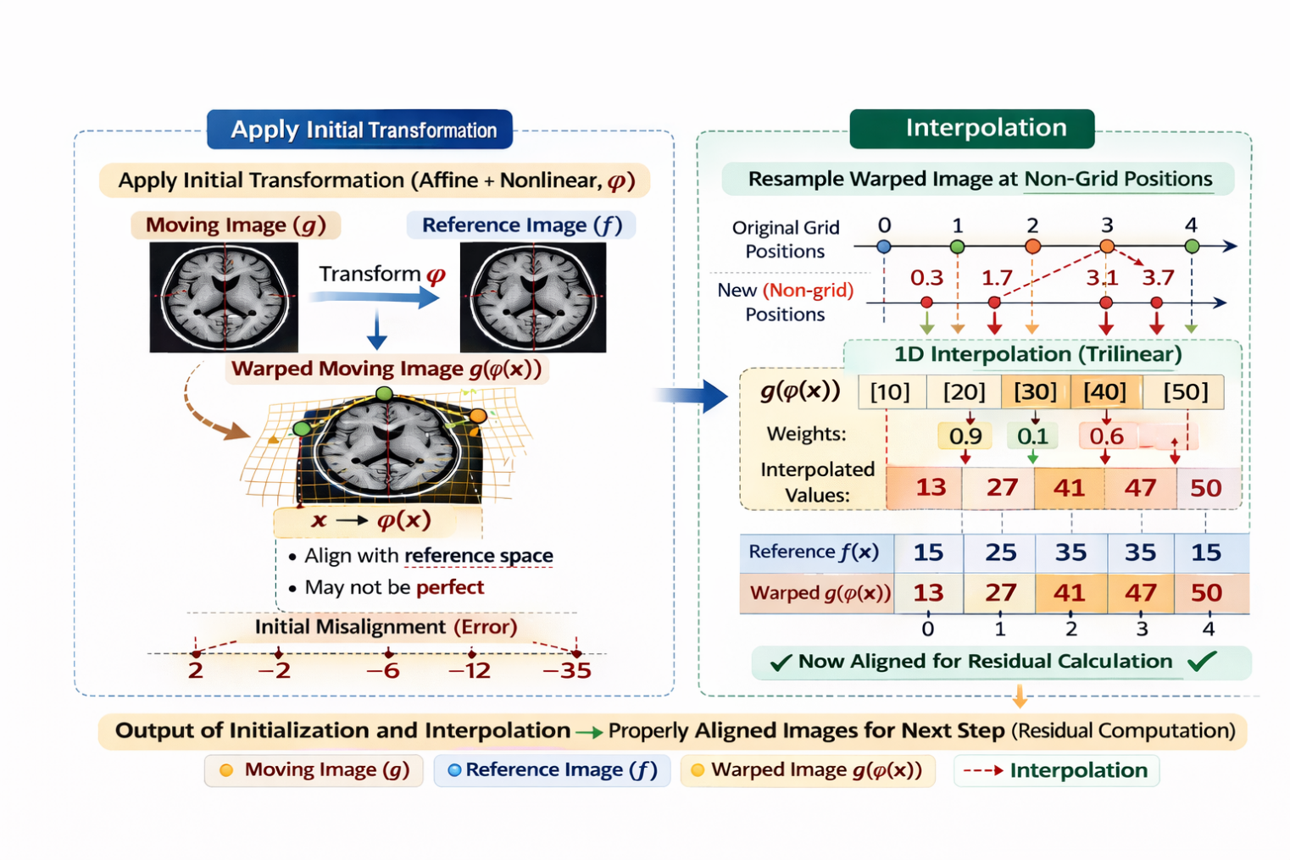
Figure: Interpolation of the Warped Moving Image

STEP 1 : Work on Reference Grid
All computations are indexed over reference voxel coordinates:
$$x∈Ω_{\text{ref}}$$
This means:
We loop over every voxel in template space.

STEP 2 : Control Point Parameterization
FNIRT does NOT optimize displacement per voxel.
Instead it defines displacement field using spline basis:
$$d(x)=\sum_{k}{c_{k}} B_{k}(x)$$
Where:
- $c_{k}=(c_{k,x},c_{k,y},c_{k,z})^{T}$
- $B_{k}(x)$= spline basis functions
This converts sparse control points → dense displacement field.
Assume one control point affecting whole volume:
$$c=\left[\begin{aligned}0.3 \\ -0.2 \\ 0.1\end{aligned}\right]$$
Since tiny volume, assume uniform warp:
$$d(x,y,z)=\left[\begin{aligned}0.3 \\ -0.2 \\ 0.1\end{aligned}\right]$$
So every voxel shifts slightly.

STEP 3 : Affine Transformation (Matrix Form)
Affine in homogeneous coordinates:
$$A=\left[\begin{matrix}a_{11} & a_{12} & a_{13} & t_{x} \\ a_{21} & a_{22} & a_{23} & t_{y} \\ a_{31} & a_{32} & a_{33} & t_{z} \\ 0 & 0 & 0 & 1\end{matrix}\right]$$
Apply to voxel:
$$x_{A}=A\left[\begin{aligned}x \\ y \\ z \\ 1\end{aligned}\right]=\left[\begin{aligned}x_{A} \\ y_{A} \\ z_{A} \\ 1\end{aligned}\right]$$

Suppose affine from FLIRT:
$$A=\left[\begin{matrix}1 & 0 & 0 & 0.2 \\ 0 & 1 & 0 & -0.1 \\ 0 & 0 & 1 & 0.1 \\ 0 & 0 & 0 & 1\end{matrix}\right]$$
This means:
- shift x by +0.2
- shift y by -0.1
- shift z by +0.1

STEP 4 : Full Nonlinear Mapping
Total transformation:
$$ϕ(x)=Ax+d(x)$$
Expanded:
$$ϕ_{x}=a_{11}x+a_{12}y+a_{13}z+t_{x}+d_{x}(x) \\ ϕ_{y}=a_{21}x+a_{22}y+a_{23}z+t_{y}+d_{y}(x) \\ ϕ_{z}=a_{31}x+a_{32}y+a_{33}z+t_{z}+d_{z}(x)$$
This gives sampling location in moving image.
Take reference voxel:
$$x=\left[\begin{aligned}1 \\ 0 \\ 1\end{aligned}\right]$$

Apply affine:
$$Ax=\left[\begin{aligned}1.2 \\ -0.1 \\ 1.1\end{aligned}\right]$$

Add nonlinear warp:
$$ϕ(x)=\left[\begin{aligned}1.2 \\ -0.1 \\ 1.1\end{aligned}\right]+\left[\begin{aligned}0.3 \\ -0.2 \\ 0.1\end{aligned}\right]=\left[\begin{aligned}1.5 \\ -0.3 \\ 1.2\end{aligned}\right]$$
This is sampling coordinate inside moving image.

STEP 5 : Interpolation (Trilinear)
Because $ϕ(x)$is fractional:
$$g(ϕ(x))=\sum_{i=1}^{8}{w_{i}} g(x_{i})$$
Where:
- $x_{i}$= 8 neighboring voxels
- $w_{i}$= interpolation weights
This builds warped image:
$$g∘ϕ$$
Trilinear Formula
$$g(x,y,z)=\sum_{i=0}^{1}{\sum_{j=0}^{1}{\sum_{k=0}^{1}{w_{ijk}}}} g(x_{i},y_{j},z_{k}$$

Where weights:
$$w_{ijk}=(1-dx)^{1-i}(dx)^{i}(1-dy)^{1-j}(dy)^{j}(1-dz)^{1-k}(dz)^{k}$$
Each weight depends on distance.
All 8 weights sum to 1.

Now compute:
$$g(1.5,-0.3,1.2)$$
Since fractional, we use weighted average of 8 neighbors.
Assume interpolated value = 34
So warped image value at (1,0,1) = 34

STEP 6 : Residual Computation
Voxel-wise mismatch:
$$r(x)=f(x)-g(ϕ(x))$$
Reference value at (1,0,1) = 35
Residual:
$$r=35-34=1$$

STEP 7 : Data Term (SSD)
$$SSD=\sum_{x∈Ω}{r(x})^{2}$$
This measures image similarity.
Suppose residual vector:
$$r=[1,-2,3,-1,0,2,-3,1]$$
Square:
$$\left[1 , 4 , 9 , 1 , 0 , 4 , 9 , 1\right]$$
Sum:
$$SSD=29$$
STEP 8 : Regularization Term
FNIRT penalizes rough warp fields.
Conceptually:
$$R(d)=∫\left({∣∇^{2}d∣}^{2}\right)dx$$
This is bending energy.
Total penalty:
$$λR(d)$$

Assume bending energy:
$$R(d)=4$$
Regularization weight:
$$λ=2 \\ λR=8$$

STEP 9 : Total Energy Function
$$E(c)=SSD+λR(d)$$
This is the objective FNIRT minimizes.

$$E=SSD+λR \\ E=29+8=37$$

STEP 10 : Compute Gradient
We compute derivative w.r.t. control points:
$$∇_{c}E=\frac{∂E}{∂c}$$
This means:
If I change a control point slightly, how much does the total energy change?
The gradient tells us:
- Which direction to move the control point
- How strongly to move it

Using chain rule:
$$\frac{∂E}{∂c}=\frac{∂E}{∂r}⋅\frac{∂r}{∂g}⋅\frac{∂g}{∂ϕ}⋅\frac{∂ϕ}{∂c}$$
This connects:
Control points → warp → sampling → residual → cost

Suppose:
$$Δc=\left[\begin{aligned}-0.1 \\ +0.05 \\ -0.02\end{aligned}\right]$$
Update Control Point
$$c_{new}=\left[\begin{aligned}0.3 \\ -0.2 \\ 0.1\end{aligned}\right]+\left[\begin{aligned}-0.1 \\ 0.05 \\ -0.02\end{aligned}\right]=\left[\begin{aligned}0.2 \\ -0.15 \\ 0.08\end{aligned}\right]$$
Recompute Everything
- rebuild warp field
- recompute φ(x)
- interpolate
- compute SSD
- compute total energy
Suppose:
$$E=20$$
Energy decreased → good direction.

Iterate Until Convergence
Repeat:
$$c→d→ϕ→\text{interpolation}→SSD→E→\text{update}$$
Until:
$$Δc≈0$$

STEP 11 : Gauss–Newton Update
Solve:
$$(H+λR)Δc=-∇E$$
Where:
- $H$= approximate Hessian
- LM damping may be added
Update:
$$c←c+Δc$$

STEP 12 : Multi-Resolution Loop
FNIRT runs multiple resolution levels:
Level 1: coarse grid
Level 2: finer grid
Level 3: full resolution
At each level:
Repeat Steps 2–11

STEP 13 : Convergence
Stop when:
$$∣Δc∣<ϵ$$
or cost change small.

STEP 14 : Final Output
FNIRT saves:
Warp coefficients:
$$c→\text{warpcoef.nii.gz}$$Therefore, FNIRT refines the initial affine alignment by estimating a smooth nonlinear deformation, enabling the subject’s anatomical image to accurately match the MNI template for reliable spatial normalization.

